H.T No
Regulations:
A17

Sreenidhi Institute of Science and Technology
(An Autonomous Institution)
Code No: 6X117 Date: 02-Aug-2018 (FN)

M.Tech I-Year I-Semester External Examination, July/Aug - 2018 (Supplementary)
Advanced Control Systems (EPE)

Time: 3 Hours Max.Marks:75

Note: a) No additional answer sheets will be provided.
b) All sub-parts of a question must be answered at one place only, otherwise it will not be valued.
c) Missing data can be assumed suitably.

Part - A Max.Marks:25

Answer all QUESTIONS.

1. | Define state transition matrix and give its properties. | [3M]
2. | Give the types of non-linearities. | [3M]
3. | State Lyapunov’s instability theorem. | [3M]
4. | Consider a SISO system 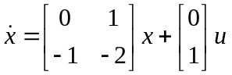and 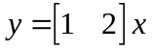.  Determine its observability when a feedback signal 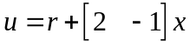is introduced. | [3M]
5. | What do you mean by constrained minimization? | [3M]
6. | State Minimum principle. | [2M]
7. | Explain principle of duality. | [2M]
8. | Define stabilizability. | [2M]
9. | What do you mean by finite and infinite time optimal control problem? | [2M]
10. | Explain minimum and absolute minimum of a function. | [2M]
Part – B Max.Marks:50
ANSWER ANY FIVE QUESTIONS. EACH QUESTION CARRIES 10 MARKS.

11. | a) | Prove that the solution of state equation is unique. | [5M]
 | b) | Consider the system given by  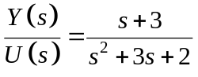.  Obtain the state space in the observable canonical form and diagonal canonical form. | [5M]
12. | a) | Obtain a phase plane portrait of the system given by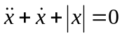. | [5M]
 | b) | Derive the describing function of On-off nonlinearity with hysteresis. | [5M]
13. | a) | What are the sufficient conditions of Lyapunov's stability? | [5M]
 | b) | Test the stability of the following system by using variable gradient method  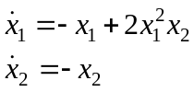 | [5M]
14. | a) | Explain the effect of state feedback on observability. | [5M]
 | b) | Consider the system defined by  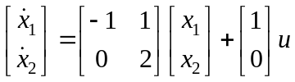.  Show that the system cannot be stabilized by state feedback control scheme 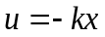. | [5M]
15. | a) | Explain minimization of functional of single function for fixed end points problem. | [5M]
 | b) | Let be the function 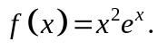  i) Find the critical points.  ii) Find the regions where is increasing and where is decreasing.  iii) Find the local maxima and minima of. | [5M]
16. | a) | Describe the linear quadratic optimal regulator problem formulation. | [5M]
 | b) | Write down the Hamiltonian equation and co-state equations for the energy optimization of the following system  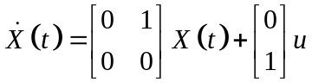. | [5M]
17. |  | Write short notes on:
 | a) | Separation principle for designing controller and observer for a system. | [5M]
 | b) | Optimal regulator design by parameter adjustment. | [5M]

-- 00 -- 00 –

